An Exploratory Study on Musharakah SRI Sukuk
for the Development of Waqf Properties/Assets in Malaysia

Zulkarnain Muhamad Sori and Nor Syahirah Zain
INCEIF, Kuala Lumpur, Malaysia

Abstract
Purpose: This study aims to explore a sustainable and responsible investment (SRI) sukuk model based on Musharakah that could be implemented to develop waqf properties and assets under the SRI sukuk framework in Malaysia. This includes proposing and designing a potential SRI sukuk model and seeking the opinion of subject-matter experts and industry practitioners on the model, its attractiveness to investors and its feasibility to implement in Malaysia.

Design/Methodology/Approach: The study adopts desk research and semi-structured interview as its methodology. A desk research is where a detailed critical review and analysis of past literature from reports, journals, framework, books and practices are undertaken. To establish a SRI sukuk model, the paper also studies the cases of the first SRI sukuk issued in Malaysia and other waqf-related sukuks that have been structured for the development of waqf property/asset in the past. Following that, the opinion of subject-matter experts and industry practitioners on the proposed SRI sukuk model is sought in a semi-structured interview.

Findings: Based on the interviewees’ response, the study proposes the most feasible SRI sukuk model that could be implemented in the Malaysian context for the development of waqf properties/assets, which is an Musharakah-based sukuk. The model will be elaborated based on the purpose of development, functionality, choice of Shari’ah contract, obligor and return mechanism.

Research Limitations/Implications: This paper is exploratory in nature. While it explores the structural point of view only, future research could analyse and identify the legal, regulatory, financial and Shari’ah aspects of the proposed model. Further empirical studies can be done to provide more comprehensive idea and knowledge regarding the subject matter.

Practical implication: The study serves great benefit to the government, waqf administrators, regulators, policy makers, foundations, corporations and interested investors to explore SRI sukuk as one of the feasible financial instruments to develop waqf in Malaysia.

Originality/Value: This study proposes the use of an innovative financial instrument called SRI sukuk and structure a feasible SRI sukuk model to help realise the true roles of waqf as not only a religious tool, but also as one of the instruments for human, economic and social developments.

Keywords: SRI sukuk, Waqf properties/assets, feasibility, Sukuk Musharakah.

Introduction
Islamic Finance started as a promising sector in the 1970s mainly focusing on Shari’ah compliant banking and hajj funds. Today, Islamic finance has grown to become an important segment in the international financial system, with estimated assets close to approximately USD2 trillion and compound annual growth rate of 15.4% (IFSB, 2016). By the end of 2018, the market size is expected to reach USD3.4 trillion (Mohammed, 2016). Concurrently, the Sustainable and Responsible Investment (SRI) has also been growing and gaining more prominence in recent years. At the start of 2016, global SRI reached USD22.89 trillion, an increase of 25% compared to USD18.28 trillion in 2014 (Global Sustainable Investment Alliance, 2016). In the United States alone, the estimated market size of SRI is estimated to be USD8.72 trillion as of 2016, a 33% increase since 2014, while SRI assets in Europe and Canada are estimated to be over USD12 trillion and USD1 trillion, respectively. This growing attention on SRI is due to the increasing awareness of policy makers and investors globally in investing in more sustainable and responsible investments that contribute to the advancements in social, environmental and governance practices (US SIF, 2016b).
In the pursuit of integrating Islamic Finance and SRI and making them relevant to the local context, the Sustainable and Responsible Investment (SRI) Sukuk Framework was launched by Securities Commission of Malaysia (SC) in 2014 as an extension of the existing sukuk framework to facilitate a conducive ecosystem for SRI investors and issuers. This framework is certainly beneficial for the natural progression of the sukuk market due to the growing awareness of investors and institutions towards ethically and socially responsible investment (MIFC, 2016). The framework lists down the projects that are eligible to be categorised under SRI projects, which include any activities related to the development of waqf properties/assets. This inclusion is meaningful because waqf asset development is a pressing issue in Malaysia. The 2012 statistics by Jabatan Wakaf, Zakat and Haji (JAWHAR) showed that there were 11,092 hectares of waqf land worth RM 1.18 billion in Malaysia. Unfortunately, only 7.2% of it was developed (Maznah, Mohamat Sabri & Radziah, 2014). It is an irony that thousands of hectares of waqf land remain undeveloped when land and property are highly in demand in the current economy (Muhammad Hisyam, 2014). Meanwhile, data on other waqf asset classes could not be provided by JAWHAR, but it is expected to have a huge value and are similarly underutilised.
This paper aims to explore an Musharakah SRI Sukuk model that could be implemented to develop waqf properties and assets under the SRI sukuk framework in Malaysia. The paper adopts desk research and semi-structured interview as its methodology. The structure of this paper is as follows: The following section reviews the literature on Islamic Finance, SRI, SRI sukuk and waqf. This includes the framework that was introduced by Malaysia’s Securities Commission on the SRI sukuk and the study of past literatures on the development of waqf in Malaysia and the modes of financing for waqf development that have been done in the past. A section on methodology follows suit as well as a section that explains the proposed Musharakah SRI Sukuk model that could be implemented in the Malaysian context for the development of waqf properties/assets. Finally, several suggestions and a conclusion will be provided.

Literature Review

Islamic Finance
Today, Islamic finance has become an important segment in the international financial system, with estimated assets close to approximately USD2 trillion and compound annual growth rate (CAGR) of 15.4% (IFSB, 2016). Despite the encouraging growth, it is argued that the true objectives of Islamic finance practice are yet to be realised. For example, Islamic financial institutions are found mostly to be profit oriented over social oriented (Mohammad & Shahwan, 2013). Hence, there has been calls for these institutions to give more effort towards bridging the gap of Islamic finance theory and practice by putting more emphasis on social responsibility and impact (Ng et al., 2015). In September 2012, Kuala Lumpur Declaration was adopted by participants in the Second Strategic Roundtable Discussion which included Shari’ah scholars and Muslim economists. One of the declaration’s critical recommendation is to broaden the organisational structures beyond traditional banking models to formats such as waqf to meet the social goals and risk sharing features of Islamic finance (ISRA, 2012). Waqf, which is part of the social sector, is rarely given the attention for further development even though it can actually bring remarkable benefits to the social welfare and justice, which is in line with the objective of Shari’ah (Ismal et al., 2015).
Therefore, it is high time for Islamic financial institutions to bridge the gap between Islamic finance theory and practice by developing and utilising tools that embody principles of Islamic finance such as SRI sukuk for the development of waqf properties and assets. To the best knowledge of the researcher, there has not been any research done in the area of SRI sukuk for the development of waqf properties and assets in Malaysia.

Sustainable and Responsible Investment (SRI)
SRI has been referred to as Socially Responsible Investment (Ministry of Finance Malaysia, 2013), Sustainable and Responsible Investment (Securities Commission, 2014), and Sustainable, Responsible, and Impactful investments (Centre for Islamic Wealth Management, 2015). According to the US Social Investment Forum (2016), SRI is integrating personal values and societal concerns into investment decisions, where investors consider both their financial needs and the impact of their investment on society. Generally, it can be referred to as any type of investment process which combines investors’ financial objectives with concerns regarding environmental, societal and governance issues (Moghul & Safar-Aly, 2015).
There are many strategies within the SRI industry. SRI Connect has listed out 21 strategies which include ethical negative screening (which incorporates Shari’ah screening), positive screening, community investing, impact investing, sustainability theme investing and ESG investing (SRI Connect). In Europe, SRI strategies through negative screening or ‘exclusions’ are estimated to be EUR17.5 trillion, making up approximately half of the total professionally managed assets in Europe (Eurosif, 2016). Impact investing was seen to be the fastest growing investment sector under SRI with a compound annual growth rate (CAGR) of 120% since 2013 amounting to almost EUR1 trillion in total assets (Eurosif, 2016). Impact investing includes the issuances of financial tools such as the green bonds, vaccine bonds and vaccine sukuk. Meanwhile in the US, at the start of 2016, there has been a 33% growth since 2014 of the US-domiciled assets under management using SRI strategies to USD8.72 trillion (US SIF, 2016a).

SRI Sukuk Framework
Securities Commission Malaysia (SC) launched the Capital Market Masterplan 2 in 2011 to promote socially responsible financing and investment. The Masterplan sets the agenda to develop a conducive environment for investors and issuers interested in SRI, and facilitate the growing trend of new financial instruments such as green bonds and Social Impact Bonds (Securities Commission, 2011). In 2013, Malaysia’s Prime Minister announced in Budget 2014 speech, that efforts will be intensified to promote Malaysia as a market for SRI (Ministry of Finance Malaysia, 2013). Subsequently in 2014, SC revised the Guidelines on Sukuk to incorporate the new requirements for the issuance of SRI sukuk.
The guideline on sukuk states that SRI sukuk issuance proceeds will be utilised for the purpose of funding eligible projects that aim to preserve and protect the environment and natural resources; conserve the use of energy; promote the use of renewable energy; reduce greenhouse gas emission; or improve the quality of life for the society. Other projects that are eligible to be categorised under SRI project include those projects with physical assets/activities related to natural resources; renewable energy and energy efficiency; community and economic development, and waqf properties/assets, which includes any projects that undertake the development of waqf properties/ assets.
The inclusion of waqf properties/assets as one of the eligible categories for SRI projects is meaningful because it provides the avenue for investors to dedicate the wealth towards perpetual returns which can benefit the society. However, the issuance of SRI sukuk for development of waqf assets is still rather unexplored. Therefore, this study attempts to explore and further develop the connection of these two areas.

Case Study: First SRI sukuk in Malaysia
The SRI Sukuk Ihsan by Khazanah is the first ever SRI sukuk to be approved under the SRI sukuk framework. This SRI sukuk has a total RM 1 billion in nominal value and the period of 25 years until its maturity. The sukuk is divided into several tranches. The first issuance on the 18th of June 2015 and second issuance on 8th of August 2017, managed to raise RM100 million respectively. The sukuk was given a rating of AAA by RAM Ratings Services Berhad (RAM Ratings, 2015), due to Khazanah Nasional being the obligor. Both issuances are intended to improve accessibility to quality education in Malaysia. According to Khazanah’s executive director of investment, Dato’ Mohd Izani Ghani, some of the next tranches may include healthcare and affordable housing.
The proceeds from the sukuk investments from each issuance are to be used to fund the roll-out of at least 20 schools under Yayasan Amir’s Trust School Programme. Yayasan Amir is a Non-Profit Organisation (NPO) incorporated by Khazanah with the aim to help improve the quality of education in Malaysian public schools through Public-Private Partnerships with the Malaysian Ministry of Education (Khazanah Nasional, 2017). Before the first SRI sukuk was issued, there were already 30 schools under the programme, encompassing rural and urban schools, and impacting more than 20,000 schools nationwide (Ghani, 2015). The strategic goals of the Trust School programme focuses on various stakeholders including: school leaders, teachers, students, parents, and the community (CIMB, 2015).
The SRI sukuk was structured based on Wakalah Bil Istithmar in which, the concept of appointment of other entities to manage sukukholders’ fund on behalf of sukukholders is applied. The first step of the structure is the appointment of Ihsan as investment representative or wakeel. Then, Ihsan appoints Khazanah as its sub-representative or sub-wakeel to manage the sukuk fund. Khazanah will then use the sukuk proceed or the sukuk fund collected from sukukholders to invest in shariah-compliant tangible assets and shariah-compliant commodity murabahah. The proceeds or profit made from these investments shall be used to fund the roll-out the schools under the Trust School Programme and shall be distributed to sukukholders until the sukuk reaches its maturity date. The illustration is shown in Figure 1.

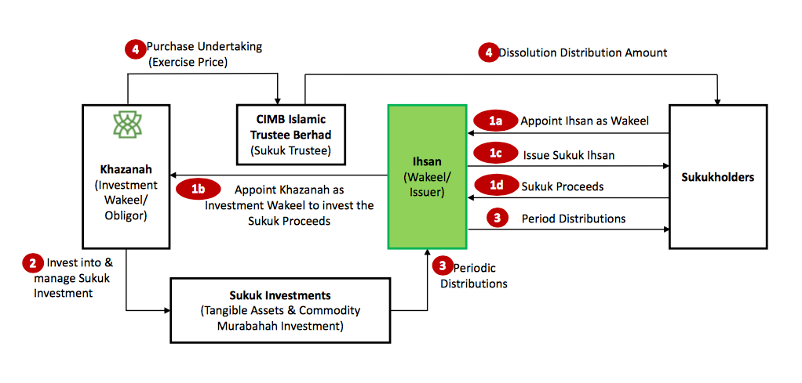
Figure 1: SRI Sukuk Ihsan
(Souce: CIMB)

The return mechanism for the SRI sukuk is based on the step-down returns structure that is dependent on the achievement of key performance indicators (KPIs). These KPIs set the required target levels for the number of Trust Schools to be implemented, performance of respective schools’ teachers, senior leadership and students. For the SRI Sukuk Ihsan to be considered a success, all the four criteria need to be fulfilled. The step-down returns structure introduced by SRI Sukuk Ihsan is the first of its kind, where the yield will be reduced when KPIs are met. This means sukukholders will actually earn less if the programme reaches its objectives as part of their social obligation in recognising the positive social impact that is generated by the Trust School Programme (Ghani, 2015). For the first issuance, the SRI sukuk was priced at a profit rate of 4.3% if the KPI are not met, or 3.5% when KPIs are been fulfilled. While the second tranche of SRI Sukuk Ihsan was recently priced at a profit rate of 4.6% if the KPIs are not met and 4.2% when KPIs are achieved.
Another feature that is unique to this sukuk is that it allows for the sukukholders to convert their investment in the sukuk into donations by exercising their “option to waive” the capital and proceeds of the sukuk (CIMB, 2015). By doing so, they are entitled to receive tax vouchers for an amount equal to the amount waived or the reduction in the nominal value of their respective sukukholdings (Ghani, 2015).

Waqf
Waqf, in the Arabic language, literally means to stop, contain or preserve. Conceptually, waqf refers to charitable endowments. It is a voluntary and irrevocable dedication of one's wealth, either in cash or kind, and its disbursement is dedicated for Shari’ah compliant projects that are beneficial (Elasrag, 2017). It transfers wealth and changes property rights from private to public. In Malaysia, waqf is administered by the respective State Islamic Religious Council (Siti Asishah & Rusnadewi, 2015).

Waqf has a great potential to be a tool for social welfare and economic development via various humanitarian projects such in the area of healthcare, education and training facilities for the society. This is why, according to Tahir, Abdul Hamid & Ismail (2005), for the interest of the beneficiaries of waqf properties and assets, the need for the existence of alternative financial mechanism is critical. The more the financial instruments there are, the more are the chances of development of the waqf.

Waqf can also be utilised as effective tools of wealth management. As most waqf are in the form of real estate, yet underutilised, there is a pressing need to develop these assets. Attempts should be made to upgrade waqf to a level where they become a sustainable source of funding and are able to generate income on their own, thereby decreasing dependency on third-party donations (Lahsasna, 2013). As waqf is to continue till no more economic benefit can be taken from the asset, an investment product or mechanism should be structured for perpetuity. What is most important is to preserve the capital. Immediate disbursement is not necessary as there is already the charitable instrument of zakat for that (Mohd Marzuki et al., 2012).
According to Anwar & Mohamad I’sa (2016), most of the Muslim and Muslim minority countries presently are moving towards promoting cash as a form of waqf. According to his findings from interviewing waqf officers and researchers in Malaysia, they believe that cash waqf can be the capital for the development of idle waqf land. However, a large number of waqf trustees (Mutawalis) are not well trained in property and financial management (Tahir et al., 2005). This calls for help from the experts in the Islamic financial sector to help manage and offer innovative financial tools like SRI sukuk.
Magda et al. (2016) had studied cases of waqf development around the world including 25 cases from Malaysia. The modes of financing used in Malaysia are joint venture, Musharakah (leasing), donations, internal funds, wakalah (agency), musharakah (partnership), waqf share, corporate waqf, state and federal funds. None has ever used SRI sukuk. One of the closest sukuk model was issued for the development of waqf was in Singapore, also known as the Bencoolen Waqf project. It is the first fundraising project to renew a waqf property in Singapore via an issuance of Sukuk Musharakah by Majlis Ugama Islam Singapore (MUIS), which will be discussed in detail in the section 2.3.3. On top of that, a Sukuk Intifa’ issued for the development of Zam Zam Tower on a waqf land in Saudi Arabia, which will be discussed in section 2.3.4. Meanwhile in Indonesia, Ismal et al. (2015) explores the potential issuance of sovereign sukuk linked to waqf assets for the development of massive local waqf that are underdeveloped or as an underlying asset of financing in a sukuk orignations. The waqf-linked sukuk issuance is intended for real economic sector development, just like a project-based sukuk. Depending on the investors’ preference, the sukuk can be fine-tuned to serve both commercial and social purposes.
On another note, according to Centre for Islamic Wealth Management (2015), the accumulated funds for the establishment of waqf projects can be realised through a number of instruments including Cash and E-Waqf Fund, Per-square Feet Value Certificate, and sukuk issuance. This paper’s focus is on the sukuk issuance, particularly is proposing several SRI sukuk models for the purpose of development of waqf assets and properties because no such model is in place at the moment.

Case Study: Sukuk Musharakah for the Bencoolen Waqf Project

The issuance of Sukuk Musharakah by Majlis Ugama Islam Singapura (MUIS) was divided into two tranches. The first tranche was a $25 million Sukuk Musharakah to purchase a building at 11 Beach Road. The second tranche was the raising of $35 million for the mixed development project at Bencoolen Street. This section will focus on the second tranche of the Bencoolen Waqf project.

The waqf property at Bencoolen Street, which was established in 1952, belongs to Shaikh Omar Bin Ali Aljunied. The intention of the waqf is to provide for the maintenance and preservation of the mosque at Bencoolen Street through income generated from the neighbouring shop-houses belonging to the waqf. The shop-houses were previously earning rental of $400 per month, which was not sufficient to cover the utilities and other fees. On top of that, the condition of the mosque and the shop-houses was poor hence needing a makeover.

The land at Bencoolen Street has a huge commercial potential, particularly for being at a very central and strategic location. The busiest and famous shopping area in Singapore known as Orchard Road and a 4-star Bencoolen Hotel are just within walking distance. Within the area are also education centres like the Singapore Management University Campus and the School of Fine Arts (Shamsiah Abdul-Karim, 2010). Hence, for this reason, MUIS proposed for a development of 104 apartments, a mosque and a 6-storey commercial complex with a cost of approximately $35 million. This was the first time that MUIS was faced with a development of such scale and an external financing has ever been attempted for developing waqf assets.

An innovative financial model was then structured for this purpose. There were two parts to model. The first part was the redevelopment through partnership (musharakah) between the waqf, Baitul Mal and Warees (a wholly owned subsidiary of Muis to handle waqf properties) to build the development at Bencoolen Street as shown in Figure 2. The waqf contributed land and some capital while Baitul Mal provided the necessary amount needed to develop it, which is the $35 million through issuance of Sukuk. Warees provided a minimal amount together with their expertise. In terms of profit distribution, as most musharakah agreements, the profit is divided accordingly as per capital invested. The investors/sukuholders through Baitul Mal shall earn a return of 3.03% which is about the rental income in the first year lease with Ascott, which will be explained next.

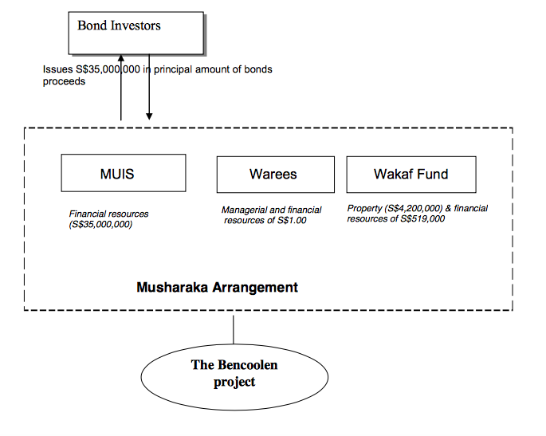

Figure 2: Sukuk Musharakah Arrangement

(Source: Shamsiah Abdul Karim, 2010)

The second part of the model is the Ijarah or leasing contract, as illustrated in figure 3. The contract was entered between the Special Purpose Vehicle (SPV) with Ascott International Pte Ltd, who agreed to lease the property for a period of 10 years. The lease for the first year amounted to $1.3 million and subsequently increased to $1.8 million from year two to year ten.

From this arrangement, the waqf got a fresh new mosque with an increase capacity and income from 4-storey of commercial properties for the mosques to sustain and run its operation. Since Baitul Mal bears most of the risk in undertaking the $35 million investment, in return it will receive the service apartment with a 99-year lease. Warees Investments Pte Ltd will receive a minimal investment return and professional fees for managing the development.

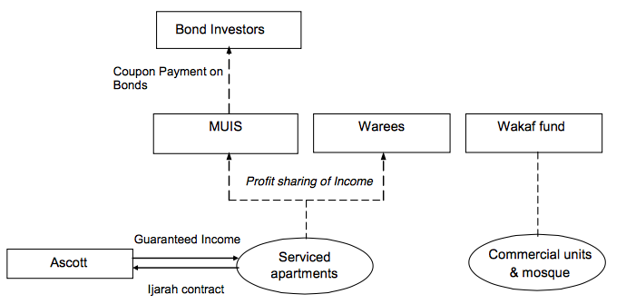

Figure 3: Ijarah between SPV and Ascott International

(Source: MUIS)

Research Methodology
As the area of research on the link between SRI sukuk and waqf is relatively unexplored, this study undertakes a combination of desk research and interview. To design the structure of an Musharakah SRI sukuk model for the development of waqf properties and assets, the best available data to achieve this is via a desk research, where a detailed critical review and analysis of past literature from reports, journals, framework, books and practices are undertaken. In the researcher’s pursuit of seeking validation and feedback on the proposed model, face-to-face interviews were conducted with subject matter experts and industry practitioners.
Since SRI sukuk and waqf are specialised niche areas, there are not many individuals who are experts in these areas. Based on the researcher’s search, the participants of the interview were then selected based on their vast relevant experience and understanding on the subject matters. The respondents who agreed to participate consist of a chairman of a bank’s Shariah Committee, two directors, a senior management, and a senior researcher at one of the top Islamic Banking and Finance institutes in Malaysia. They are all based in Kuala Lumpur and have had experience in dealing with sukuk, either as an issuer, investor, researcher or evaluator. A summary of the respondents is given in Table 1.

Table 1: Summary of Respondents

Organisation | Individual | Respondent’s Position
A | A1 | Chairman
B | B1 | Senior Researcher
C | C1  C2 | Director  Vice President
D | D1 | Director

Musharakah SRI Sukuk Model
This model is inspired by the Sukuk Musharakah for the Bencoolen Waqf project in Singapore as mentioned in the previous section. Sukuk Musharakah is an equity based sukuk that is based on partnership. The sukuk-financed musharakah project can be managed either on the basis of participation (musharakah), mudaraba or investment agency (Investment & Finance, 2014).
The model begins with the government or the Majlis Agama Islam Negeri (MAIN) or State Islamic Religious Council first identifying a specific social or economic issue that needs attention, like the issues of affordable housing and unemployment. The waqf development will then be aimed to be an income-generating asset while solving the intended social problem. This is similar to the Seetee Aishah waqf development, where the development of the waqf land helped to provide affordable housings in Pulau Pinang, Malaysia (Hydzulkifli, Asmak, Ahmad Rizal, Azizi, & Suhaila, 2013).
Figure 4 and the explanations below provide the details on the proposed Model 2.
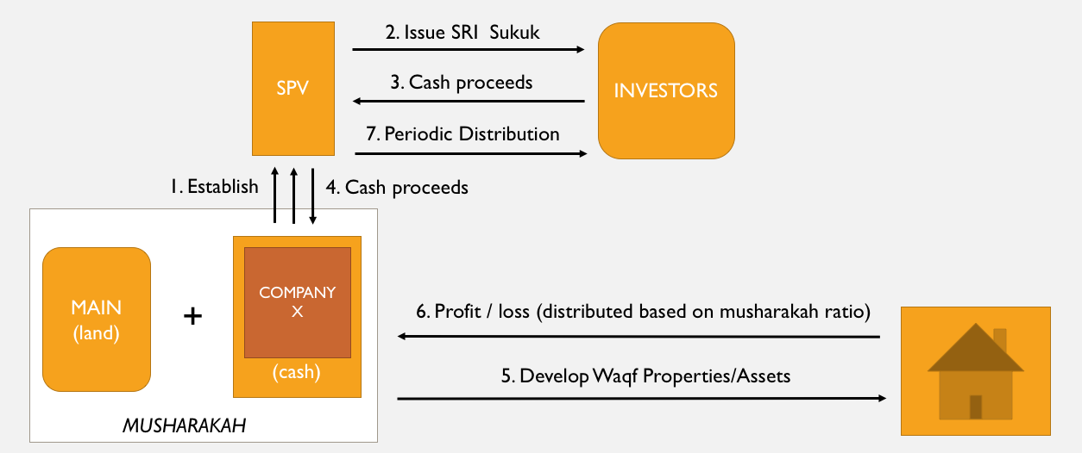
Figure 4: SRI Sukuk model based on Musharakah

In this model, Majlis Agama Islam Negeri (MAIN) and Company X enter into a Musharakah (profit and loss sharing partnership) to develop waqf properties/assets.
- Company X establishes SPV.
- SPV issues SRI sukuk.
- Investors provide the cash.
- SPV gives the cash proceed to the Musharakah.
- Together, they develop the waqf properties/assets.
- Income gained from the development of waqf properties/assets will be shared among the partners.
- Company X will share the income with investors based on an agreed percentage.

The proposed obligor for this model is the Government or MAIN based on two reasons. The first reason is having the government as the obligor has proven to increase the worthiness and rating of the sukuk and secondly, as the development of waqf would benefit the society, the responsibility of providing these social services should be taken upon by the government as the caretaker of its people. The obligor is needed in the models to execute the obligations of the issuer (SPV) should it fails to observe.
The researcher is also keen on having the return mechanism to investors be based on KPIs. Unlike the SRI Sukuk Ihsan that has a step-down returns mechanism as described in the previous section, the researcher proposes for a step-up returns structure where investors would be getting higher returns if KPIs are achieved and lower returns if KPIs are not achieved. This is so that it becomes a motivation for all parties to ensure the success of the waqf development project. The KPIs can be anything set and agreed by all parties. Examples include setting the number of waqf properties and assets that should be developed by Company X within a certain period of time and that the development happening on the waqf should be income generating and benefitting the community. On top of that, replicating the SRI Sukuk Ihsan, the three models also provide the sukukholders the “option to waive” the capital and returns from the sukuk, hence converting their investment in the sukuk into donations. By doing so, they are entitled for tax vouchers of an amount equal to the amount waived or the reduction in the nominal value of their respective sukukholdings.
The researcher sought the interviewees’ feedback on the proposed Musharakah SRI Sukuk model and its feasibility to be implemented in Malaysia.

Feedback from Interview
- Shari’ah Contract
Generally, all the respondents are agreeable with the chosen underlying Shari’ah contract for the model in terms of its Shari’ah compliancy as Musharakah is an approved contract under the Securities Commission’s Sukuk Guidelines.
However, respondent B1 is of the opinion that while MAIN and Company X can partner in a Musharakah partnership, the relationship between the SPV and the investors should be a Mudarabah relationship, where the investors are only the cash provider (rabbul maal), but business management is in the hand of the company. Meanwhile, D1 prefers for an Ijarah arrangement to be between SPV and investors, as according to him, this would appeal to investors more than an equity-based arrangement. This suggestion is consistent with the Sukuk Musharakah arrangement for the Bencoolen Waqf project, where the return to investors are based on Ijarah.
Respondent C2, on the other hand, thinks that a Mudarabah structure is more preferred instead of a Musharakah for M2 as a whole, particularly between MAIN and Company X. This is because as a government agency, MAIN would be highly reluctant to take in losses from a Musharakah arrangement. While in Mudarabah, the loss will be borne solely by the corporation or rabbul maal.
- Return Mechanism
The responses for this section are divided into two parts. Part one discusses when should the returns be given to the investors given that the development project will take time, while part two discusses the respondents’ comments on the KPI return mechanism.
All respondents agreed that the disbursement of returns to investors do not have to wait until the completion of the development project, which might take a few years. It can be given since year one via a contract like Musharakah Mawsufah Fi Dhimmah, or also known as forward leasing, between Company X and the customers. Besides forward leasing, according to respondent B1, there could also be a “technical arrangement” that set out payment to be made once the development project starts. Payment is made based on the progress made, which is similar to an Istisna’ arrangement, but not quite. According to him, a “technical arrangement” is easier to be arranged compared to having an additional standalone contract like Istisna’ which could have Shari’ah implications. Multiple contracts in one transaction is a very delicate matter which needs to be assessed carefully to avoid unnecessary future implications (Lateh, 2016).
As for having the KPIs included in the return mechanism, a mixed response was received from the respondents. Respondent A1 does not see the need of having KPIs embedded in the return mechanism. For this a Musharakah model, the return to investors is dependent on the return received from the business, not necessarily the KPIs. Similarly, according to C2, KPIs are not needed because the interests of all parties are already aligned. All parties are already together and motivated to ensure the success of the project so that returns are maximised. C1 then added that if anything, the existence of KPIs would be a turn-off to investors. Meanwhile, D1 is of the opinion that KPIs would work best for non-income generating projects like the Trust School project by Ihsan, which is not the same as the proposed model which are aimed to finance income generating projects.
- Obligor
The interviewees were asked to comment on the choice of obligor proposed by the researcher, which is the government or MAIN. All respondents are agreeable to the choice of government as the obligor and think it would be the most ideal arrangement. However, according to respondent C1, in practice, “there is zero chance” of getting the government to be the obligor. Echoing C1’s statement, C2 shared one of the reasons for that is because government receives proposals all the time but due to its limited budget, only promising or projects that have shown success in the past would be more likely to be considered. Expectedly, it is trying to reduce its contingent liability as most governments do.
On the other hand, according to respondents C1, C2 and D1, MAIN would not be a feasible choice of obligor as it does not have the credit standing. Since waqf asset cannot be pledged and MAIN cannot take liability, corporation is most likely expected to take up all the risks to the project. Therefore, in the Malaysian practice, there is a much higher chance for a corporation to be the obligor compared to the government, as seen in Khazanah being the obligor for the SRI Sukuk Ihsan structure.
On another note, respondent A1 suggested for a Musharakah takaful fund to be set up to act as a risk reserve. Though it is not impermissible from a Shari’ah point of view to manage the risk as such, it does move away from what a true Musharakah should be, that is being at risk. Since MAIN and Company X are Musharakah partners in M2, MAIN cannot be the obligor as one partner cannot guarantee the other partner. However, according to Section 8.02(b) of the Sukuk Guidelines by Securities Commission, it is allowable to have a Kafalah (guarantee) on musharakah capital provided by a third party, with or without imposition of fee. Meanwhile, C2 thinks that perhaps a buy-out structure should be included in the model. What he meant by this is when the partnership hits a certain financial target, the partnership can slowly dissolve.
- Interest by investors and feasibility to be implemented in Malaysia
Respondents A1, B1 and D1 believe that investors would be less interested in Sukuk Musharakah most equity-based Sukuk. However, having said that, B1 added that at the end of the day, just like any other investments, the bottom line matters. Investors would want to know what will they get from the investment. He also mentioned that how the SRI sukuk is marketed is important. If the Musharakah SRI sukuk model is advertised from a religious perspective, investors might not be interested. D1 shares the same opinion. He thinks that the structure is not the main concern of investors. They will be keen if the investment generates return, it is well marketed and the benefits of investment can be seen in the long run, which becomes a ‘feel good factor’ knowing that they are contributing to the society.

Revised Musharakah SRI Sukuk Model
Taking into considerations the feedback and suggestions by the respondents, below is the revised version of the Musharakah SRI Sukuk model:
The model begins with the government or the Majlis Agama Islam Negeri (MAIN) or State Islamic Religious Council first identifying a specific social or economic issue that needs attention, like the issues of affordable housing and unemployment. The waqf development will then be aimed to be an income-generating asset while solving the intended social problem.
Figure 5 and the explanations below it provide the details of the revised and proposed SRI sukuk model for the development of waqf properties and assets.

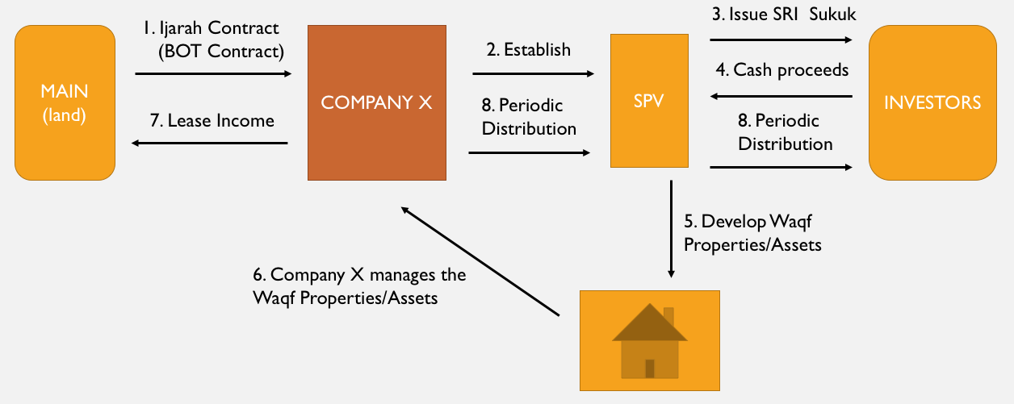
Figure 5: The revised SRI Sukuk model based on Musharakah

In this model, Majlis Agama Islam Negeri (MAIN) and Company X enter into a Musharakah (profit and loss sharing partnership) to develop waqf properties/assets.
- Company X establishes SPV.
- SPV issues SRI sukuk.
- Investors provide the cash.
- SPV gives the cash proceed to the Musharakah.
- Together, they develop the waqf properties/assets.
- Income gained from the development of waqf properties/assets will be shared among the partners.
- Company X will share the income with investors based on an agreed percentage.

Based on the feedback from the interview, the following changes are made. Firstly, on the choice of obligor. The most realistic obligor for this model will be Company X or any other private corporation even though ideally, the government is most preferred. The obligor will guarantee the completion of the project as well as execute the obligations which the issuer (SPV) fails to observe.
Secondly, the model will not have the KPIs embedded in the return mechanism for three reasons. Firstly, the structure of the sukuk has had all parties motivated to ensure the success of the project so that returns are maximised. The SPV must develop income generating assets and Company X must manage efficiently to get the returns. Secondly, taking into consideration the respondents who have had experience with KPIs in SRI Sukuk Ihsan, setting KPIs is expensive and therefore increases the cost of issuance. Finally, having KPIs might resist investors from investing because returns are dependent upon the performance of the KPIs. However, having said that, like SRI Sukuk Ihsan, investors will have the “options to waive” their rights, benefits and entitlements to the periodic distributions and the capital into the sukuk. By doing so, they are entitled to receive tax vouchers for an amount equal to the amount waived or the reduction in the nominal value of their respective sukukholdings.
Finally, as per respondent A1’s suggestios, a Musharakah takaful fund is to be set up to act as a risk reserve. Though it is not impermissible from a Shari’ah point of view to manage the risk as such, it does move away from what a true Musharakah should be, that is being at risk. However, the risk reserve will provide an acceptable level of comfort for the investors particularly in the event of losses.

Conclusion
The Islamic finance industry has shown positive growth since its inception. However, despite this progress, the full potential of Islamic finance industry has not been realised and there have been calls to close the gap between theory and practice. This study has pioneered an exploratory research on SRI sukuk as an innovative financing tool to develop waqf properties and assets. With the proposal of Musharakah SRI sukuk model that could be implemented for the development of waqf properties and assets, the study serves great benefit to the government, waqf administrators, regulators, policy makers, foundations, corporations and interested investors to explore. Policy makers should take a bold step in improving the way waqf assets are managed currently and realise that not only SRI sukuk could be structured to support the financing of waqf assets development into viable income-generating assets that can help with social programmes, it can also help to materialise the true potential roles of waqf as not only a religious tool, but also one of the instruments for human, economic and social developments in Malaysia as well as globally.

References
Anwar, A. P., & Mohamad I’sa, A. J. (2016). The constraints of Malaysian mutawalli in developing idle waqf lands. Proceedings of the Muktamar Waqf Iqlimi III (IQLIMI 2016), 2016(October), 13–14. http://doi.org/10.13140/RG.2.2.11520.84483
CIMB. (2015). Ihsan Sukuk Berhad: Information Memorandum. Malaysia: CIMB.
CIWM. (2015). SRIs & The Case for Islamic Investment Funds. Retrieved from http://www.mifc.com/repository/0186SRI e-Book.pdf
Elasrag, H. (2017). Towards A New Role of the Institution of Waqf. Retrieved from https://mpra.ub.uni-muenchen.de/80513/
Eurosif. (2016). 2016 European SRI Study. http://doi.org/10.1080/14634980802171106
Ghani, M. I. (2015). The World's First Ringgit-Denominated SRI Sukuk. In T. Reuters (Ed.), Thomson Reuters - RFI Responsible Finance Report 2015: The emerging convergence of SRI, ESG and Islamic Finance: Thomson Reuters.
Global Sustainable Investment Alliance. (2016). Global Sustainable Investment Review.
Hydzulkifli, H. O., Asmak, A. R., Ahmad Rizal, M., Azizi, A. B., & Suhaila, A. K. (2013). The Structuring for Development and Management Waqf Properties in Malaysia Ibn al-Ath ī r stated that originally the word asset ( m ā l ) has been used amongst and silver 1 . The scope of meaning for the term m ā l has been extended to all to physical goo. Journal of Human Development and Communication, 2, 45–59.
IFSB. (2016). Islamic Financial Services Board Stability Report 2016. Bank Negara Malaysia (Vol. 1).
Investment & Finance. (2014). Musharakah Sukuk. Retrieved July 13, 2014, from http://www.investment-and-finance.net/islamic-finance/m/musharakah-sukuk.html
Ismal, R. I. R., Muljawan, D., Chalid, M. R., Muljawan, D., Chalid, M. R., Sastrosuwito, J. K. S., & Sastrosuwito, J. K. S. (2015). Occasional Paper Awqaf Linked Sukuk To Support the Economic Development Awqaf Linked Sukuk To Support the Economic Development.
ISRA. (2012). Kuala Lumpur Declaration. The Second Strategic Roundtable Discussion ISRA-IRTI-DURHAM University, (September), 1–3.
Khazanah Nasional. (2017). Khazanah Nasional Berhad - Khazanah to issue second tranche of Sustainable and Responsible Investment (SRI) Sukuk. Retrieved August 18, 2017, from http://www.khazanah.com.my/Media-Downloads/News-Press-Releases/2017/Khazanah-to-issue-second-tranche-of-Sustainable-an
Lahsasna, Dr. Ahcene. (2013, 27 November 2013). Family Waqf as a Wealth Management Tool. Paper presented at the Islamic Wealth Management Seminar, Kuala Lumpur, Malaysia.
Lateh, B. (2016). Multiple Contract and Fatwa of National Sharia Council. International Journal of Nusantara Islam, 4(1), 41–48. http://doi.org/http://dx.doi.org/10.15575/ijni.v4i1.1184
Magda, I. A. M., Dafterdar, H., Cizakca, M., Syed Othman, A., Shaikh Hamzah, A. R., Seyed Kazem, S., … Obaidullah, M. (2016). Financing the Development of Old Waqf Properties: Classical Principles and Innovative Practices around the World. Kuala Lumpur: Palgrave Macmillan US.
Maznah, Z., Mohamat Sabri, H., & Radziah, A. L. (2014). Pelaporan Wakaf di Malaysia : Mengenalpasti Keperluan Maklumat Pemegang Kepentingan. Persidangan Kebangsaan Ekonomi Malaysia Ke-9, 9, 226–233.
MIFC. (2016). SRI & Green Sukuk : Challenges & Prospects.
Ministry of Finance Malaysia. (2013). The 2014 Budget.
Moghul, U. F., & Safar-Aly, S. (2015). Green Sukuk: The Introduction of Islam’s Environmental Ethics to Contemporary Islamic Finance.
Mohammad, M.O. & Shahwan, Sue. (2013). The objective of islamic economic and islamic banking in light of maqasid al-shariah: A critical review. Middle East Journal of Scientific Research. 13. 75-84. 10.5829/idosi.mejsr.2013.13.1885.
Mohammed, N. (2016). The Size of the Islamic Finance Market.
Mohd Marzuki, M. U., Shahimi, S., Ismail, A. G., & Embong, Z. (2012). Tackling Poverty : A Look At Cash Waqf. Prosiding Perkem Vii, 2, 1611–1623.
Muhammad Hisyam, M. (2014). Unleashing the Potential of Waqf.
Ng, A., Mirakhor, A., & Ibrahim, M. H. (2015). Risk Sharing and Social Impact Partnerships. Social Capital and Risk Sharing: An Islamic Finance Paradigm. Palgrave Macmillan.
RAM Ratings. (2015). RAM Ratings Assigns AAA(s) Preliminary Rating to Malaysia’s First SRI Sukuk Programme. Retrieved from http://www.ram.com.my/pressReleaseView.aspx?ID=18c18604-695e-4d6c-b5b6-62d958a70c79
Securities Commission. (2011). Capital Market Masterplan 2.
Securities Commission. (2014). Press Release: SC Introduces Sustainable and Responsible Investment Sukuk Framework. Retrieved from https://www.sc.com.my/post_archive/sc-introduces-sustainable-and-responsible-investment-sukuk-framework/
Shamsiah Abdul-Karim. (2010). CONTEMPORARY SHARI’AH STRUCTURING FOR THE DEVELOPMENT AND MANAGEMENT OF WAQF ASSETS IN SINGAPORE. Durham University. Retrieved from http://etheses.dur.ac.uk/778/
Siti Asishah, H., & Rusnadewi, A. R. (2015). Towards Improvement of the Rights and Duties of Mutawalli and Nazir in the Management and Administration of Waqf Assets.
SRI Connect. (n.d.-a). 21 SRI Strategies. Retrieved from https://www.sri-connect.com/index.php?option=com_content&view=article&id=2&Itemid=81
SRI Connect. (n.d.-b). Prejudices About SRI Investment Performance. Retrieved from https://www.sri-connect.com/index.php?option=com_content&view=article&id=7&Itemid=86
Tahir, M., Abdul Hamid, M. I., & Ismail, O. (2005). An Ideal Financial Mechanism for the Development of the Waqf Properties in Malaysia, 1–168.
US SIF. (2016a). 2016 Trends Report Highlights Snapshot of US Sustainable , Responsible and Impact Investing. Retrieved from http://www.ussif.org/files/Trends/US SIF 2016 Trends Overview.pdf
US SIF. (2016b). SRI Basics. Retrieved from http://www.ussif.org/sribasics

Shaik Omar Bin Ali Aljunied, an Arab merchant, was born in 1792 and passed away in the year 1852. In 1821 he took up residence in Singapore and built the Mosque in 1845.
Muis Annual Report 1999
Singapore Management University (SMU) is the 3rd University in Singapore catering to the niche area of business & law.
For the purpose of anonymity, names of individuals and their respective organizations have not been revealed.

